Speaking Nº3

|  |  |
| --- | --- |
| Objective | Identificar los cuantificadores. |
| Name |  |
| Instructions | Escribe los cuantificadores que faltan en el espacio vacío.  Te dejo un link para que aprendas más sobre los cuantificadores:  <https://www.youtube.com/watch?v=-oll5WNHWAk&t=33s> |

Tema: Cuantificadores

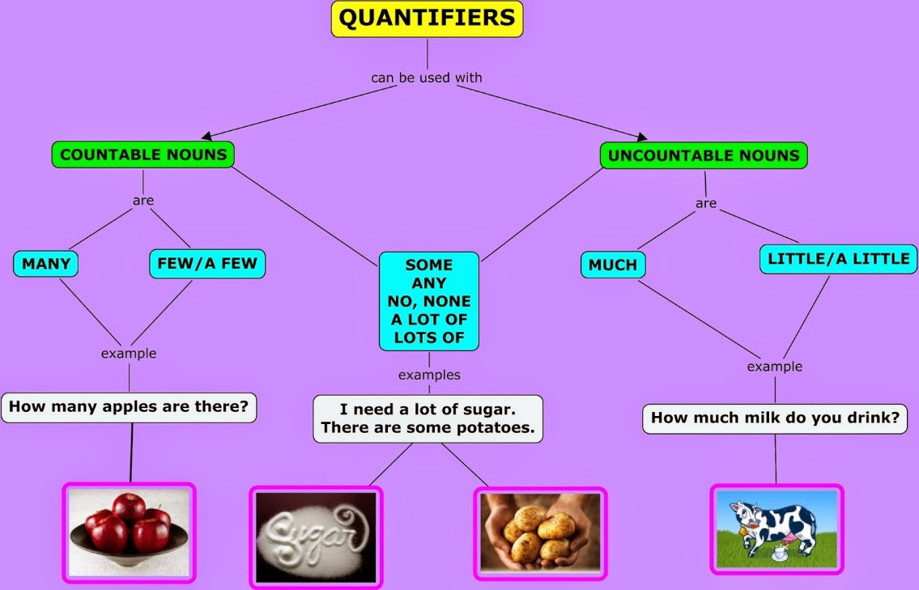

I.- Write the missing quantifiers in the empty space. (Escribe los cuantificadores que faltan en el espacio vacío.)

### There was______________people in the restaurant on Monday morning.

### Give me______________seconds, I need more time to complete the activity.

### Please buy______________apples, I am going to prepare an apple pie.

1. We had a______________water to drink after the exercise.
2. ______________people understood his comment.
3. ______________days after his thirteenth birthday, Tony graduated from school.
4. She has______________self-confidence. She has trouble talking to new people.
5. Luckily, there is______________crime in my town.
6. I have______________ money, enough for the cinema at least.
7. I have______________arguments with my family.

Responde estas preguntas en tu cuaderno y luego pregúntalas a tus compañeros de clases.

|  |  |
| --- | --- |
| **How often do you take a shower?** | **How often do you go to the cinema?** |
| **How often do you go to school?** | Resultado de imagen para book dibujo **How often do you read books?** |
| **How often do you wear shorts?** | Resultado de imagen para vegetables dibujo **How often do you eat vegetables?** |
| Resultado de imagen para speak english **How often do you speak English?** | Resultado de imagen para coffee dibujo**How often do you drink tea?** |
| Resultado de imagen para pintando dibujo**How often do you paint pictures?** | Resultado de imagen para chinese food dibujo**How often do you eat chinese food?** |