Writing Nº1
Objective | Identificar vocabulario del estado de la salud.
Name
Tema: Estados de la salud

I. Match the problem and the suggestion. (Relaciona el problema con la sugerencia.)

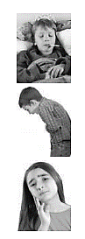

A. You shouldn’t eat an hamburger.
B. You should go to the dentist.
C. You should stay in bed and rest.
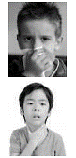
D. You shouldn’t scream.
E. You should see a doctor.

II.- Look at the picture and match with the correct word. (Mira la imagen y relaciónala con la palabra correcta.)


I have an earache
I have a headache
I have a stomach ache
I have a toothache
I have flu

I have a cough
I have a sore throat
