Writing Nº3
Tema: “Conectores For/Since”
Objective | Identificar el uso de conectores “For” y “Since” utilizándolos en oraciones.
Nombre
Instructions | Observa el video para aprender más sobre los “for” y “since”. Luego, complete las siguientes oraciones usando las palabras “for” y “since” correctamente de acuerdo con el contenido de cada ejercicio.
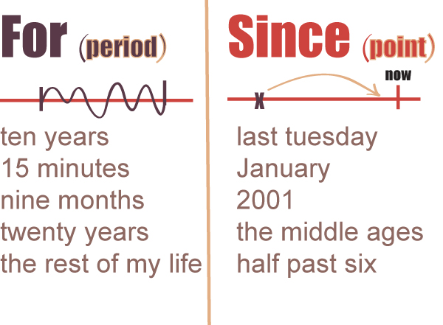
https://www.youtube.com/watch?v=fzNU2Mkz_m4
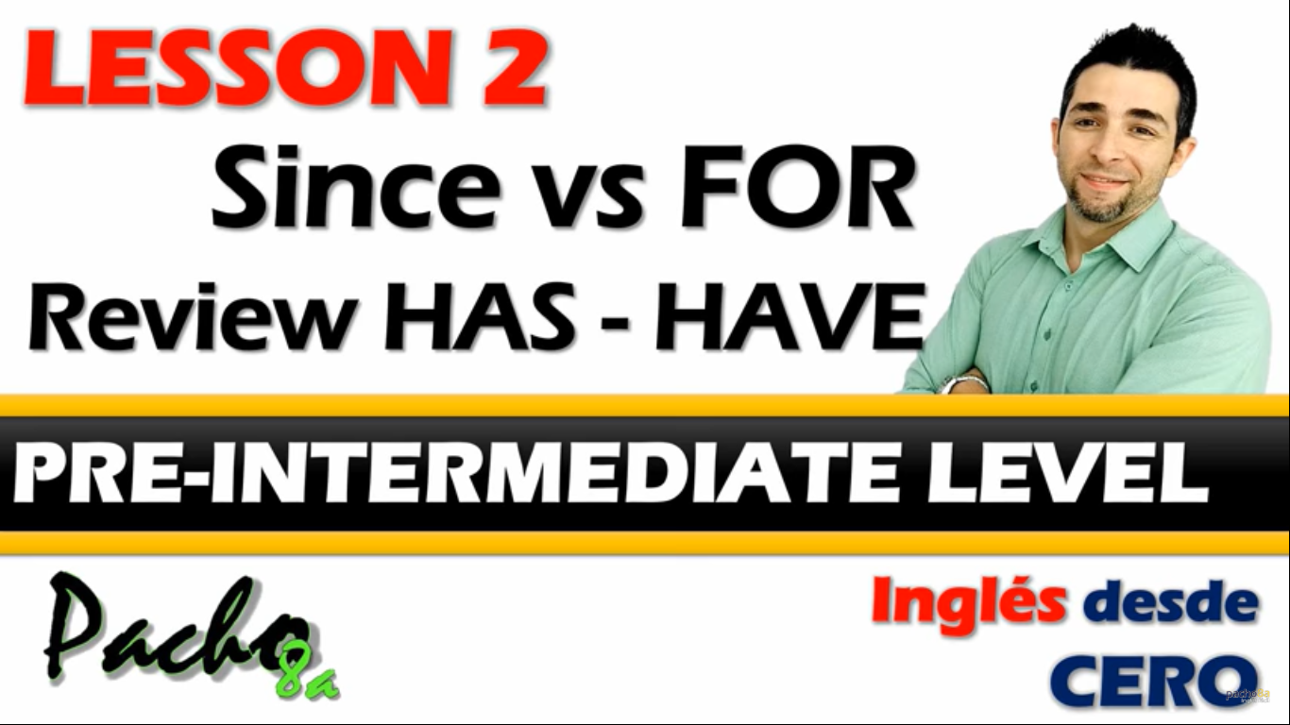

Activity

I. Complete the next sentences by using the words “for” and “since” properly according to the content of each exercise. (Complete las siguientes oraciones usando las palabras “for” y “since” correctamente de acuerdo con el contenido de cada ejercicio.)

a) Arthur has worked in this bank ____________ 1999.

b) We have been here ____________ three hours and nothing has happened.

c) I haven’t seen Karen ____________ we were kids.

d) John and Mel have been married ____________ twenty years.

e) We haven’t been to the beach ____________ the beginning of the summer.

f) The baby has been asleep ____________ hours.

g) We have been best friends ____________ over 25 years.

h) They have had the same old car ____________ a long time.

II. Answer the next questions about your own personal information with both uses of “for” and “since” properly. (Responda las siguientes preguntas sobre su propia información personal con ambos usos de "for" y "since" correctamente.)

a) How long have you lived where you live now?
(for) ______________________________________________________________

(since) ____________________________________________________________

b) How long have you studied in this school?
(for) _______________________________________________________________

(since) _____________________________________________________________

c) How long have you studied English?
(for) _______________________________________________________________

(since) _____________________________________________________________

d) How long have you known your best friend?
(for) _______________________________________________________________

(since) _____________________________________________________________

e) How long have you had your schoolbag?
(for) ________________________________________________________________

(since) ______________________________________________________________

III. Choose the correct choice in the next multiple-choice activity related to the use of “for” and “since” properly. (Elija la opción correcta en la siguiente actividad de opción múltiple relacionada con el uso correcto de "for" y "since".)

1.- I've had my computer ..... more than five years.
- For
- Since

2.- She has spoken 3 languages ..... she was a child.
- For
- Since

3.- It's ok. I've only been waiting ..... a few minutes.
- For
- Since

4.- I haven't played tennis ..... I came to Germany.
- For
- Since

