Lámina de resumen N°2

Curso: III Medio

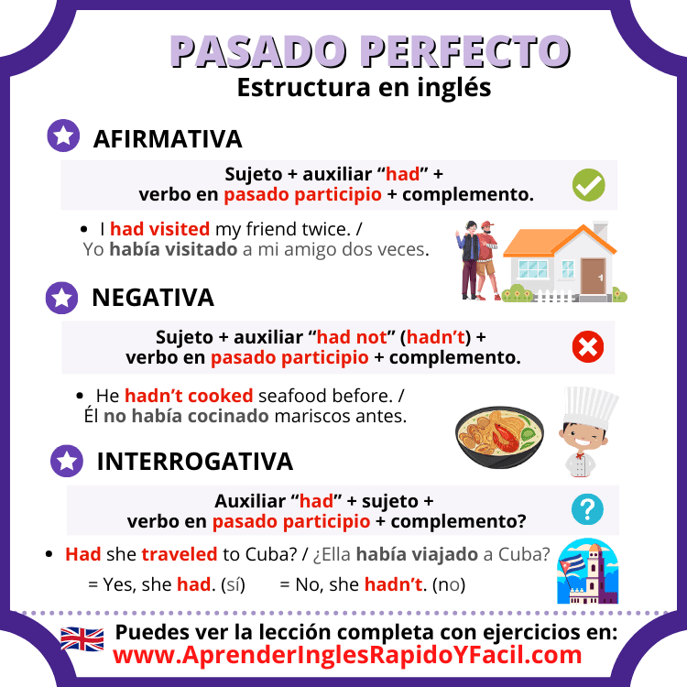

### 

### 🔸 Speaking Time: ****Preguntas que la profesora puede hacer en la evaluación:****

1. Can you introduce yourself, please?
2. Why do you want to work here?
3. What are your strengths and weaknesses?
4. What experience do you have in this field?
5. What did you do in your last job (or internship)?
6. How do you handle stress or teamwork?
7. Where do you see yourself in five years?
8. Do you have any questions for us?