Reading Nº3

Tema: Comparative and Superlative

|  |  |
| --- | --- |
| Objective | Comprender el uso de los comparativos y los superlativos a través de textos. |
| Name |  |

**I. Look** at the picture and complete the sentences using the comparative or the superlative for the adjectives in brackets of each exercise. (Observa la imagen y completa las oraciones usando el comparativo o el superlativo de los adjetivos entre paréntesis de cada ejercicio.)

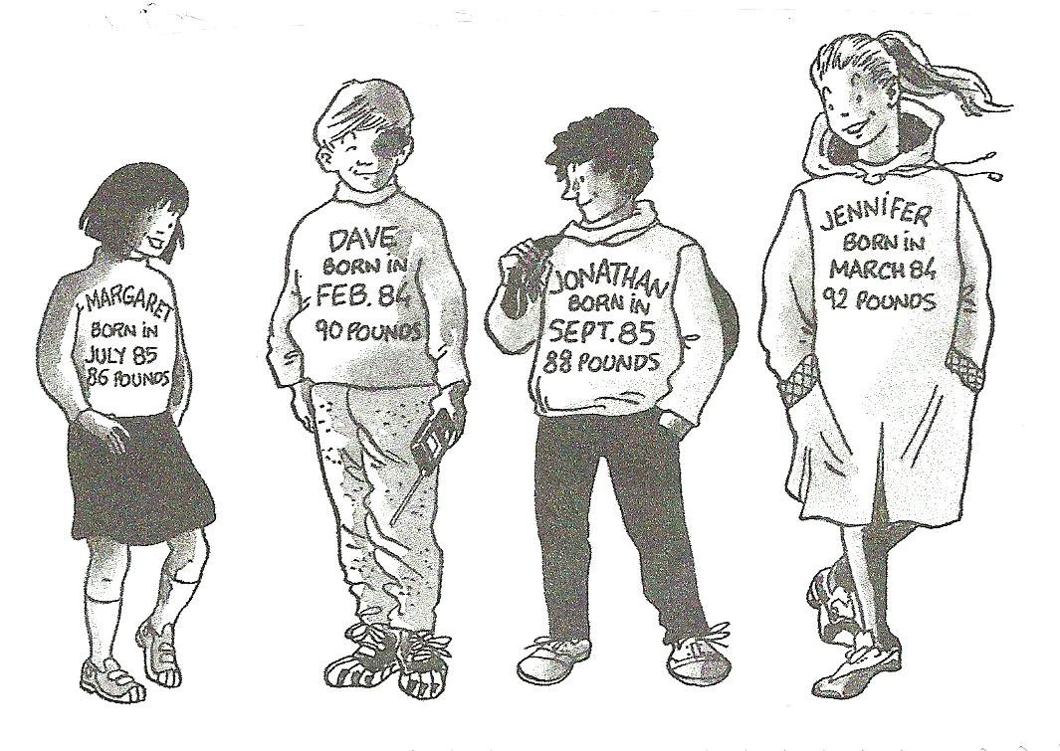

1. Margaret is (heavy) _____________ than Jonathan.

2. Dave is the (old) _____________ but he is (light) _____________ than Jennifer.

3. Margaret is (young) _____________ and (light) _____________ than Jennifer.

4. Dave is (tall) _____________ than Margaret but he’s (short) _____________ than Jennifer.

5. Jennifer is (heavy) _____________ and (tall) _____________.

6. Dave is (old) _____________ than Jonathan and (heavy) _____________ than Margaret.

7. Margaret is the (short) _____________.

8. Margaret is (young) _____________ and (light) _____________ than Dave.

9. Jonathan is (short) _____________ and (light) _____________ than Dave.

10. Jonathan is (young) _____________.

11. Dave is (old) _____________ than Margaret but Margaret is (light) _____________ than him.

12. Jonathan is (tall) _____________ than Margaret but (short) _____________ than Dave and Jennifer.

13. Jonathan is (light) _____________ than Dave but he’s (heavy) _____________than Margaret, though Jennifer is (tall) _____________.

II. Write the correct comparative and superlative form for the next adjectives below.( Escribe la forma correcta de comparativo y superlativo para los siguientes adjetivos a continuación.)

|  |  |  |
| --- | --- | --- |
| **ADJECTIVE** | **COMPARATIVE**  **ADJECTIVE** | **SUPERLATIVE**  **ADJECTIVE** |
| a) Big |  |  |
| b) Light |  |  |
| c) Short |  |  |
| d) Sunny |  |  |
| e) Rainy |  |  |
| f) Long |  |  |
| g) Hot |  |  |
| h) Cold |  |  |
| i) Old |  |  |
| j) Far |  |  |