Reading Nº4

Tema: Grandes descubrimientos

|  |  |
| --- | --- |
| Objective | Identificar la forma pasiva y activa en texto escrito. |
| Name |  |

Activity

I.- Read the text and complete with the passive form of the verbs in parenthesis. (Lee el texto y completa con la forma pasiva de los verbos entre paréntesis.)

**The History of Paper**

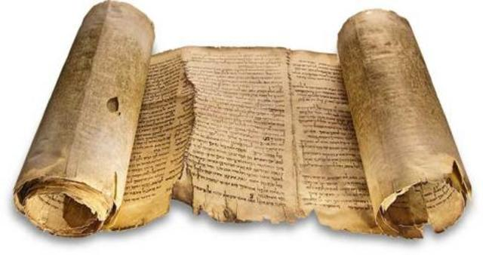Today, paper (1) ______________ (use) for hundreds of everyday things –books and newspapers, of course, but also money, stamps, cups, bags, and even some clothes.

Long ago, before paper, people (2) _______ (write) on animal skins, bones, and stones. Then in 2700 BC, the Egyptians (3) ___________ (start) to make papyrus, which was similar to paper (4) ______________ (invent) in 105 ADD by a Chinese government official, Ts’ai Lun. It (5) _____________ (make) from a mixture of plants and cloth. The Chinese (6) ______________ (keep) their invention secret for centuries.

Finally, in the 10th century, paper (7) _________________ (bring) to Europe by the Arabs. The first European paper mill (8) _______________ (build) in Spain in 1150. Since the 18th century, most paper (9) __________________ (make) out of wood, because it is much stronger than cloth. Nowadays, each person (10) _______________ (use) about 300 kg of paper every year. That’s a lot of paper!