Vocabulary Nº5
Tema: Ocupaciones

Objective | Reconocer vocabulario de las ocupaciones en textos escritos.
Name
When I Grow Up…
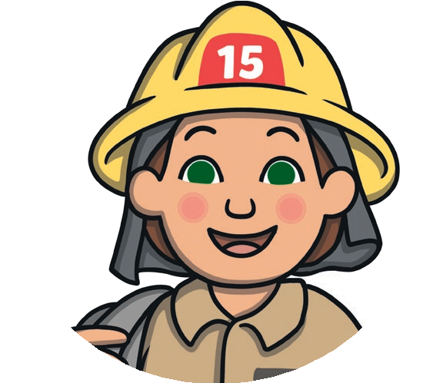

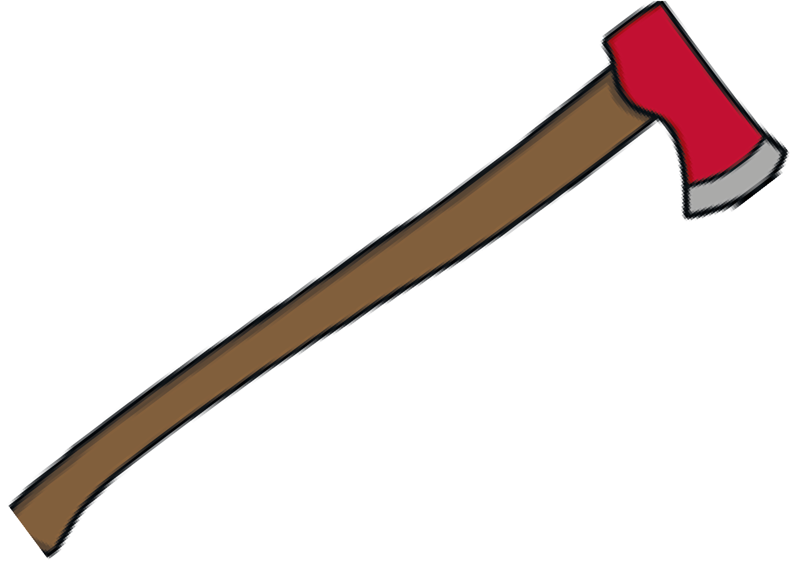
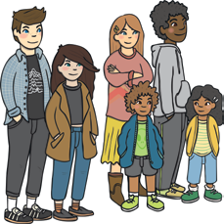
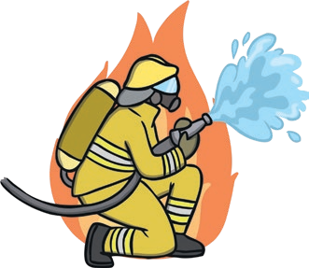
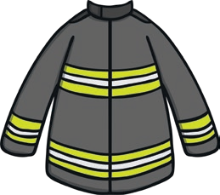
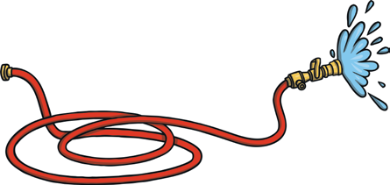
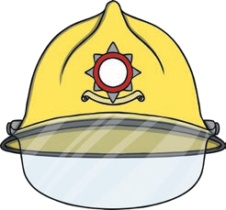
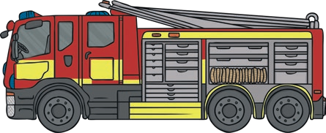
Word Bank
firefighter
uniform
helmet
axe
hose
fire engine
people

- When I grow up, I’d like to be a __________________________________________.
- Firefighters wear __________________________________________________________.
- They use __________________________________________________________________.
- They drive a __________________________________________________________________.
- They help __________________________________________________________________.

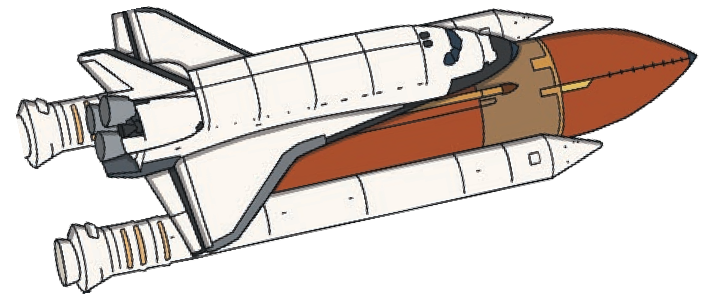
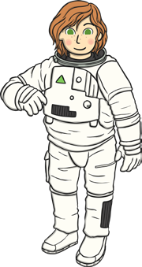
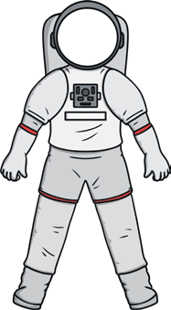
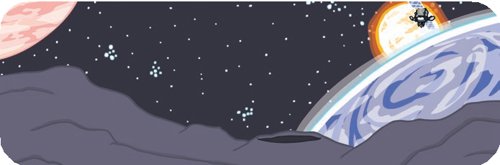
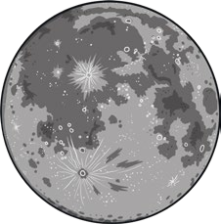
Word Bank
astronaut
the Moon
spacesuit
rocket
space

- When I grow up, I’d like to be an .
- Astronauts wear .
- They go into .
- They travel in a .
- They explore ______________________________________________________.


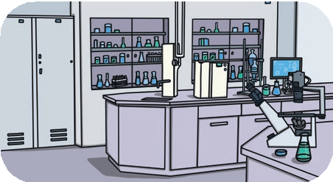
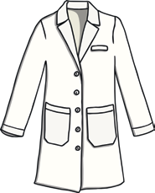

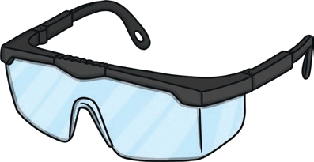
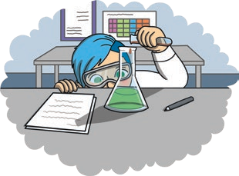
Word Bank
scientist
lab coat
safety goggles
lab
chemicals
experiments

- When I grow up, I’d like to be a .
- Scientists wear .
- Scientists work in a .
- Scientists sometimes use .
- Scientists do __________________________________________________________________________

