Writing Nº2

Tema: Acciones (Verbos)

|  |  |
| --- | --- |
| Objective | Reconocer y usar verbos de acción en oraciones simples para describir actividades diarias. |
| Name |  |

1. Match the verb with the picture (Relaciona el verbo con la imagen)
2. Run
3. 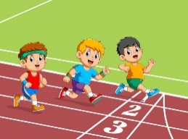Eat
4. 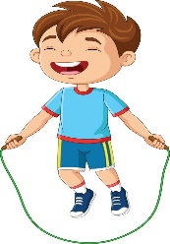Jump
5. 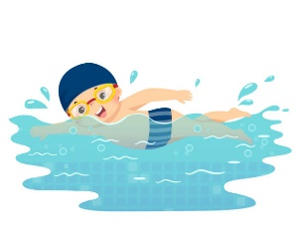Swim
6. Sing

II. Complete the sentences with the correct action verb (Completa las oraciones con el verbo de acción correcto):

|  |
| --- |
| run – eat – play – dance – swim |

1. I ____________ in the pool.
2. They ____________ soccer in the park.
3. We ____________ fast in the race.
4. She ____________ a delicious cake.
5. He ____________ at the party.

III. Draw the action (Dibuja la acción):

🔹 Draw a person running.

|  |
| --- |
|  |

🔹 Draw a person eating.

|  |
| --- |
|  |

🔹 Draw a person jumping.

|  |
| --- |
|  |

IV. Extra Challenge (Desafío extra): Write a short sentence with these verbs. (Escribe una pequeña oración con el uso de estos verbos.)

*(Ejemplo: I run in the park.)*

1. Run: ___________________________________________________________________________.
2. Play: ___________________________________________________________________________.
3. Swim: _________________________________________________________________________.