Writing Nº4

Tema: Ser un entrevistador

|  |  |
| --- | --- |
| Objective | Comprender el modo de una entrevista de trabajo. |
| Name |  |
| Instructions | This is your chance to find out about the world of work. Choose someone you know, who you think has an interesting job, and ask them some of these questions to find out about how they started working in their chosen career. (Esta es tu oportunidad de conocer el mundo laboral. Elija a alguien que conozca, que crea que tiene un trabajo interesante, y hágale algunas de estas preguntas para saber cómo empezó a trabajar en la carrera que eligió.) |

**The person I am interviewing is**

What is your job?

Was this what you wanted to be when you were younger?

How did you become interested in the job you now do?

How many jobs have you had and what were they?

Did you need any qualifications to get your job?

Can you tell me a little bit about your job and what you do?

What skills do you need to have to be successful at your job?

Do you enjoy your job? Why?

What are some of the challenges you face in your job?

What type of person would you recommend your job to?

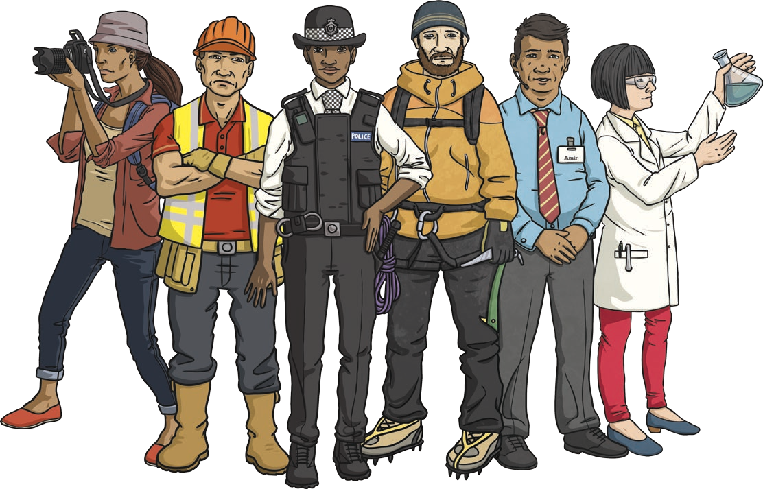

* Realiza una presentación oral acerca de tu persona entrevistada comentado lo más importante que menciono en su entrevista.