**Taller N 6 Lenguajes verbal.**

**Vocales.**

|  |
| --- |
| **NOMBRE:** |
| **FECHA:** |

* Colerea solo las vocales I.

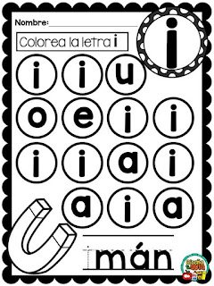

* Une la vocal I con el elemento que corresponda.

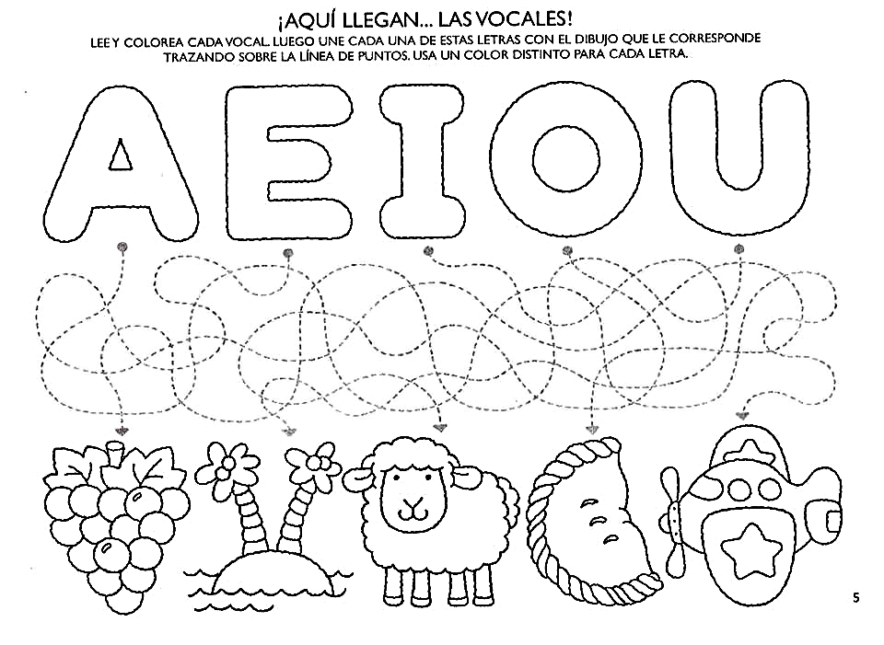

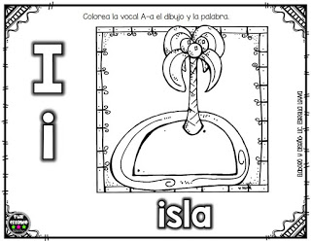

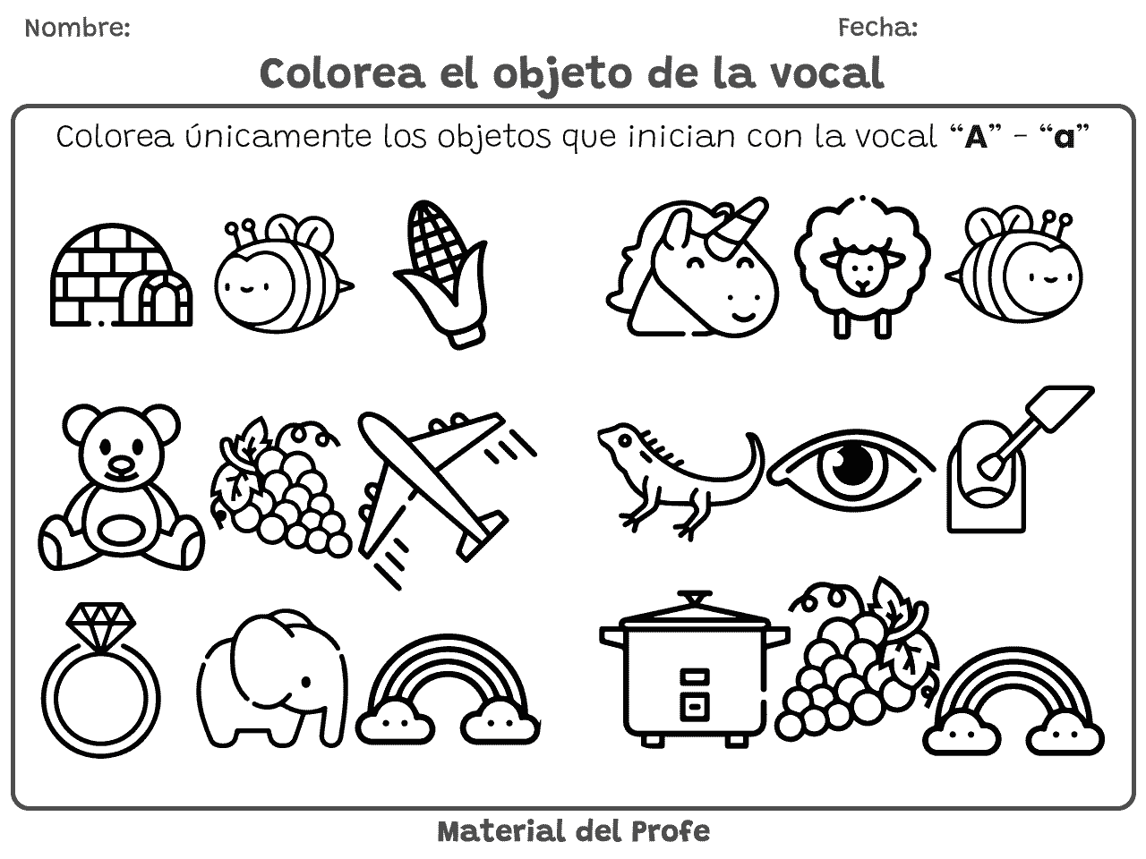

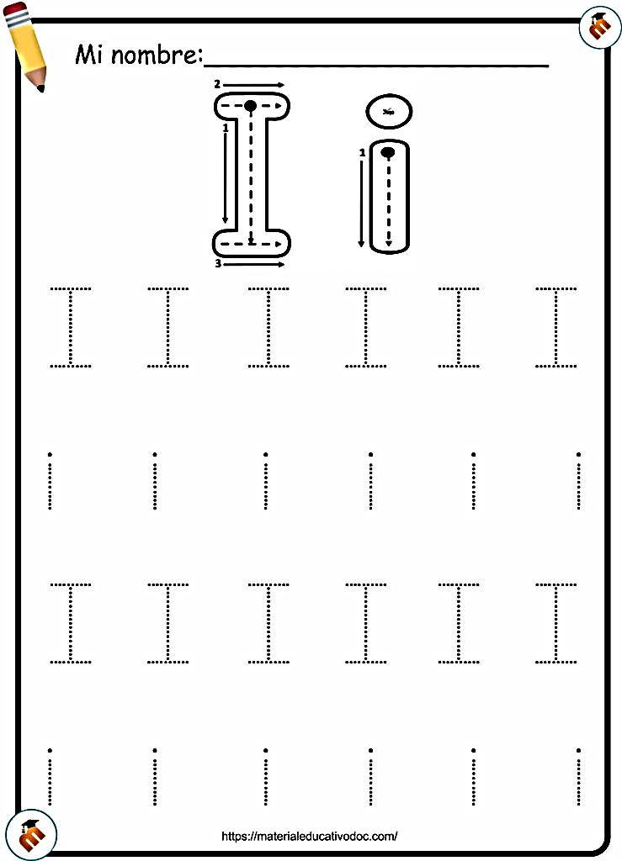

* Completa

|  |  |  |  |
| --- | --- | --- | --- |
| I | I | I | I |
|  |  |  |  |

|  |  |  |  |
| --- | --- | --- | --- |
| i | i | i | i |
|  |  |  |  |